NOTICE OF PUBLIC HEARING - CITY OF EVANSVILLE PLAN COMMISSION
Public Hearing Date: August 5, 2019 at 6:00PM
Public Hearing Location: City Hall, 31 South Madison St, Evansville, WI
Application Number(s): CUP-2019-07 Applicant: Landmark Services Coop
SUBJECT SITE
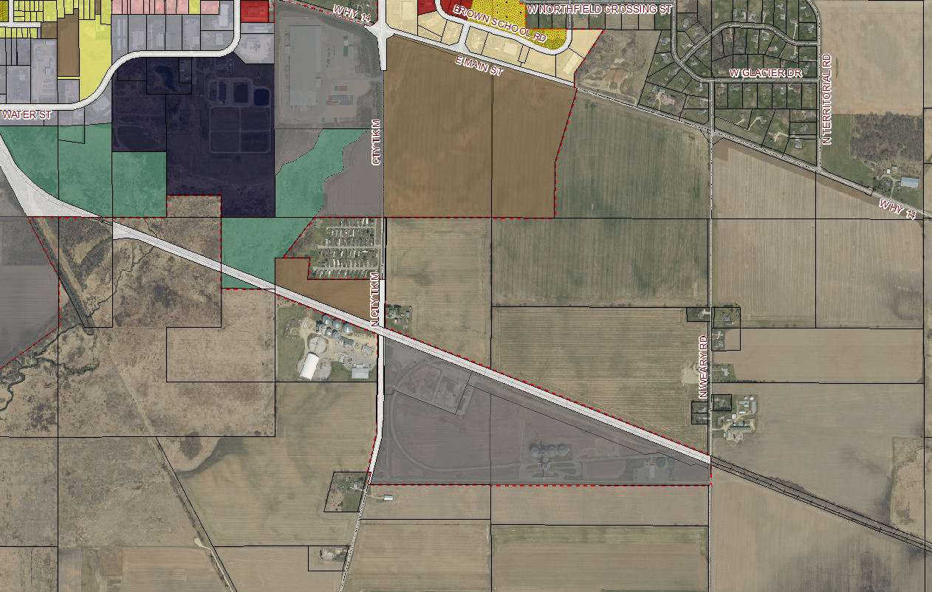
More information available at: ci.evansville.wi.gov/current
Direct questions and comments to Community Development Director: Jason.sergeant@ci.evansville.wi.gov or 608-882-2285

PLEASE TAKE NOTICE that an application for a conditional use permit on parcel 6-27-1200, 6-27-1200.1, 6-27-1160, and 6-27-1160.1 at 6401 N Weary Road has been submitted for consideration by the Plan Commission. The request is to construct an approximately 64,000 SF dry fertilizer storage building as part of an agricultural services group development. The Plan Commission will conduct a public hearing on the land division request at the time and place listed above. A copy of the application is available at City Hall, 31 South Madison Street, for public viewing during regular business hours. All interested parties are invited to attend the hearing and provide comment.

